**EXPERIMENT-11**

**Submitted by:**Ajay Kumar Tyagi  
500067403  
R171218008  
CSE-DevOps

**Aim:** To install minikube and understand its fundamentals.

**Procedure:**

**1)** To install minikube in your windows system, got to <https://minikube.sigs.k8s.io/docs/start/> and download it.  
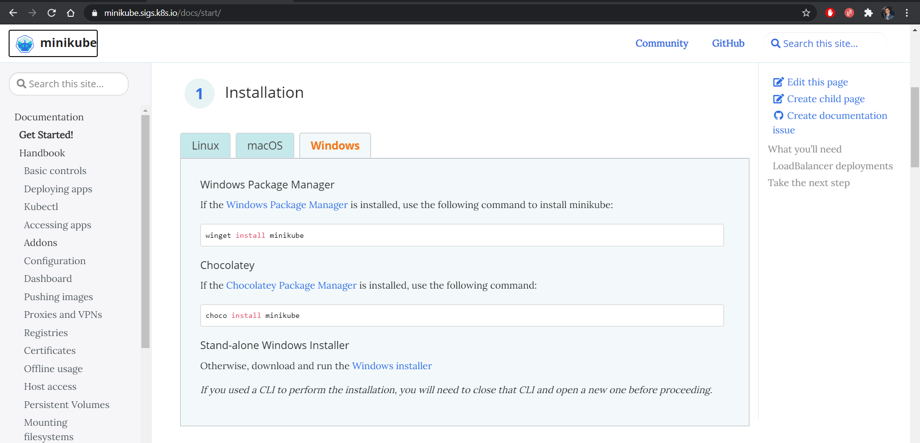

**2)** To start using minikube, you must have installed Oracle virtual box. Add minikube to your environment variable.  
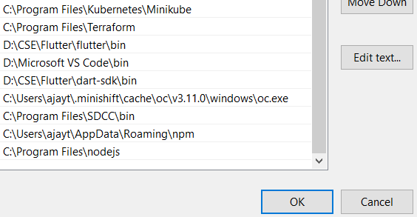

**3)** Use command **minikube start** to start your k8s cluster.  
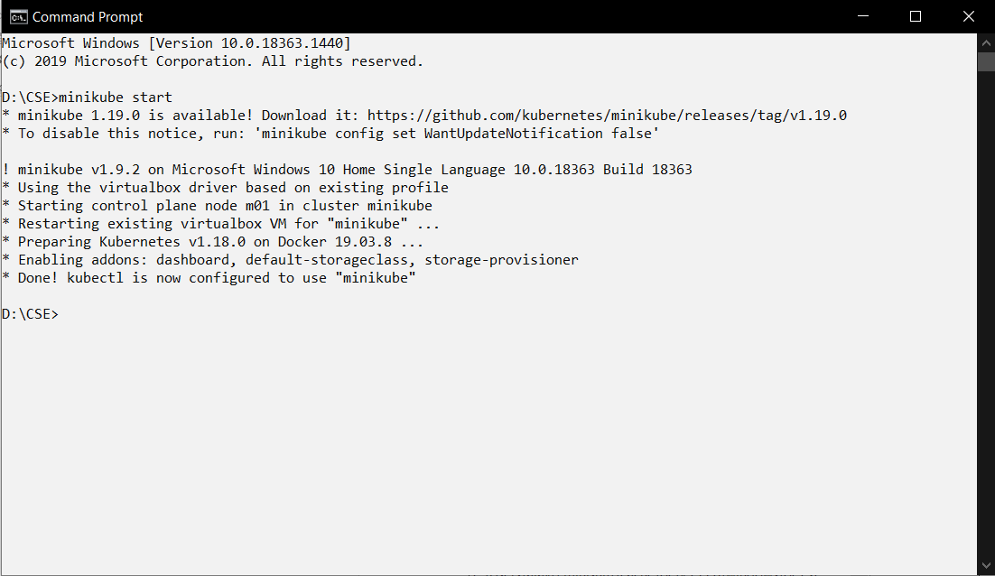

**4)** Now go to <https://kubernetes.io/docs/tasks/tools/install-kubectl-windows/> and download **kubectl** tool. This tool is used to contact to k8s cluster.  
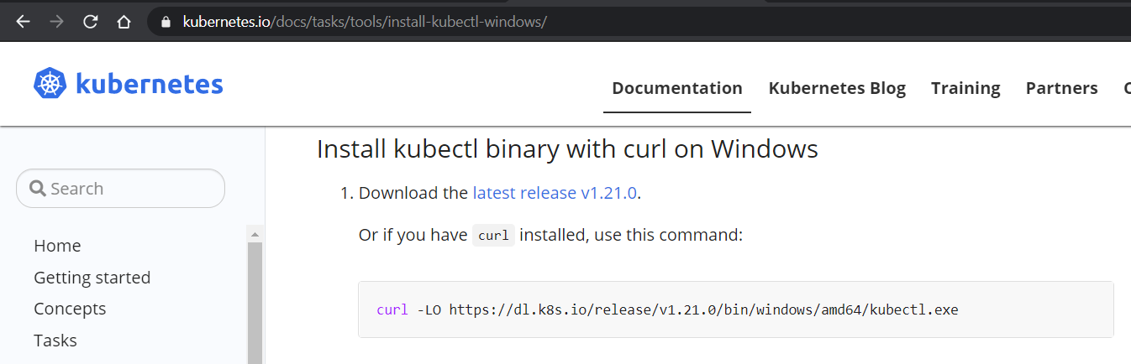

**5)** Now our k8s setup is complete. Use kubectl to run commands on k8s cluster.  
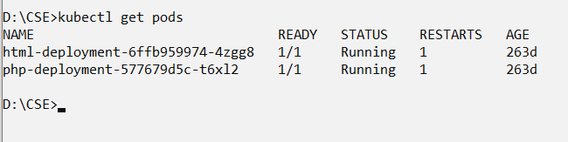

**6)** At last use command **minikube stop** to stop your k8s cluster.  
